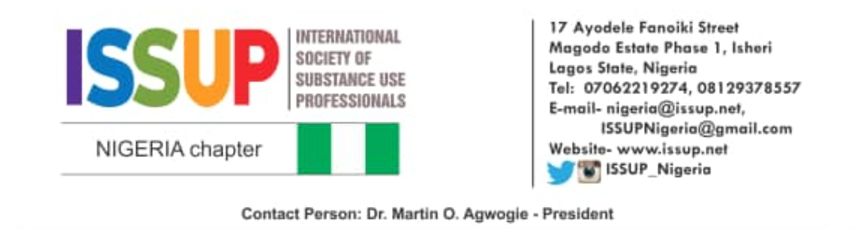
Ref: ISSUPNC/01/ADM/VOL.1/004 May 11, 2020
PRESS RELEASE

SUBSTANCE USE PREVENTION AND TREATMENT IN THE COVID-19 PANDEMIC

We are an umbrella group of professionals dedicated to the prevention and treatment of substance use disorders among Nigerians. With over 14 million people who use different psychoactive substances in Nigeria, the burden of substance use is great and concerted efforts are required to reverse the worsening rate of substance use problems in the country.
The COVID-19 pandemic has presented governments around the world with significant challenges to their economy, health administration and specifically prevention and treatment of substance use problems.
Particularly worrisome to us, as an association, is the fact that measures put in place to tackle the pandemic and reverse it, inadvertently increase the risk for the burden of substance use problems because:
- Isolation and physical distancing may limit access to treatment and aftercare
- Lockdowns may increase the number of persons who hitherto had no problems developing substance use problems
- Mental health problems may trigger or worsen substance use problems, arising from fears about the uncertainty of global economies and rising job losses, homelessness and insecurity
- Physical distancing may promote loneliness and lead to relapse
- Prevention strategies are difficult to implement and sustain in this pandemic
As a result of the following, ISSUP Nigeria encourages:
- Professionals to embrace e-health or tele-health approaches during these times
- Clients and support groups to take advantage of support available online
- Government to continue with policy reform and legislative activity that would strengthen substance use prevention and treatment in Nigeria
- Government and the general public to be vigilant and help to mitigate risk factors that could expose individuals to substance use during and after the pandemic.
ISSUP Nigeria would continue to ensure that her members provide ethical and evidence-based treatment strategies in pursuit of holistic care for persons with substance use disorders as well as prevention.
We pledge our support to the government in providing drug treatment to persons who use drugs and are in any of the COVID-19 isolation centres in Nigeria.

Dr. Martin O. Agwogie
National President
08023265398

