ISSUP News submission

Create News
News should be recent items related to Substance Use Disorders within the public health field including policy change, supply control issues, stories of evidence-based practice etc.
Title

Create a short title (ideally 1 – 10 words)
UNODC supports the continuity of services under COVID-19, in Côte d'Ivoire, through procurement of Personal Preventive equipment to the Ministry of Health for the attention of community-based services, centres and organizations, for treatment and care for drug use disorders in September 2020

Country

Côte d’Ivoire

Source Language
French

Image

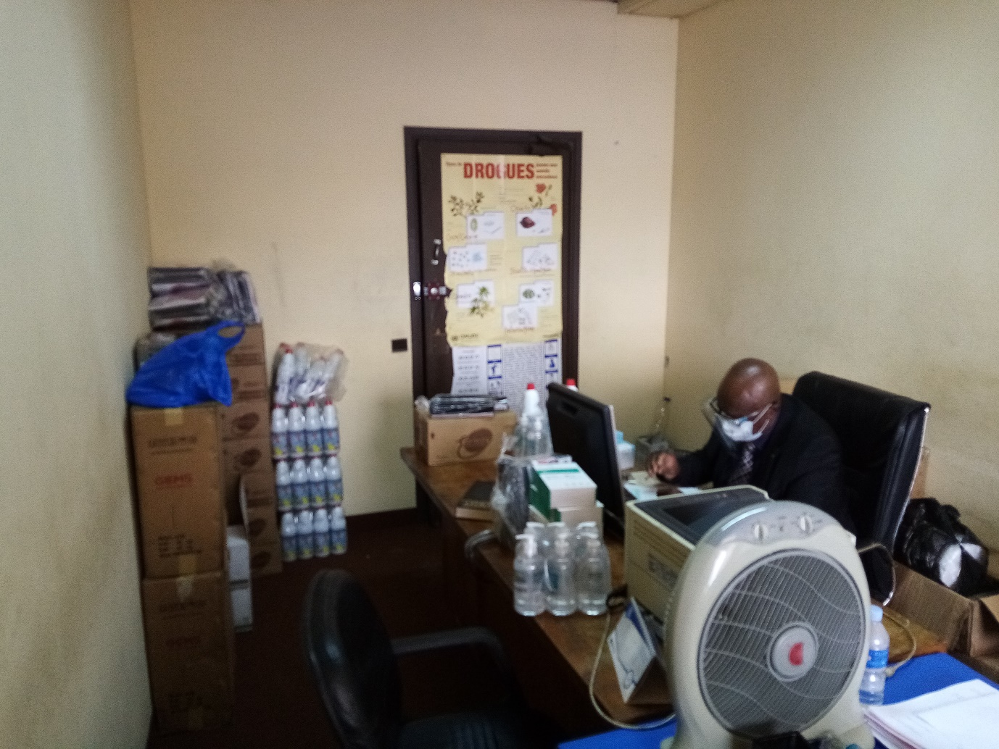
Receipt of donations to the Interministerial Anti-Drug Control Committee (CILAD)

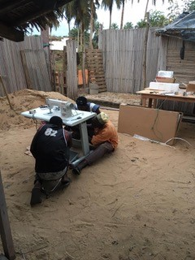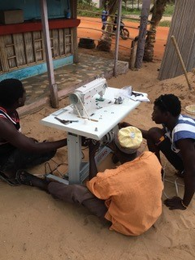
Sewing machine for reusable masks

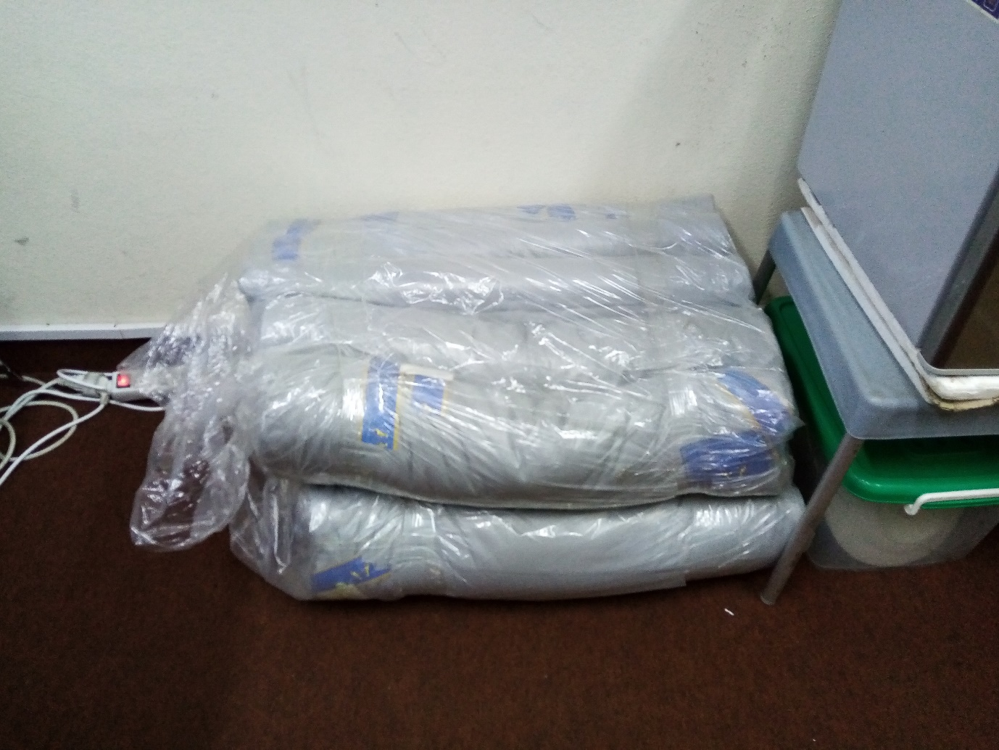

Inputs for the manufacture of reusable masks

Inputs for the manufacture of reusable masks

Please ensure the image is your own, not taken from any other source unless you have express permission to use.
One file only. 64 MB limit. Allowed types: png gif jpg jpeg.

Video

Paste the link to your video content on YouTube or Vimeo

Body (150 words)
To support the continuity of treatment and care services for drug use disorders, PTRS / GLOK32 through UBRAF funds, following a webinar on continued access to treatment held in June 2020, supported the Ministry of Health in Côte d'Ivoire with the provision of personal protective equipment to services and centers and the procurement of a sewing machine to manufacture reusable masks for a community-based organization to promote the safe and secure availability of treatment and care services under the COVID-19 health crisis for people with drugs use disorders. The reusable masks manufacturing equipment will allow the Assouindé Therapeutic Community to maintain its care and to start income-generating activities related to sewing for the most vulnerable.

Insert the main body of your text here. Please ensure the content is your own words, not taken from any other source unless you have express permission to use the content. Ensure you reference appropriately. Where you are writing about another source please ensure you link to the original content.

Links

URL

https://www.unodc.org

This must be an external URL such as http://example.com.

Link text

Please ensure you upload the URL of the news item you are writing about.

Attachments -add a file

Tags (Keywords)

Please add as many tags as you require here, separated by commas. Please start typing and click on the suggested tag if your suggestion has already been used.

An ISSUP moderator will review and publish your post within the next 7 days.

