UGANDA YOUTH DEVELOPMENT LINK (UYDEL)
Commemoration of the international women’s day
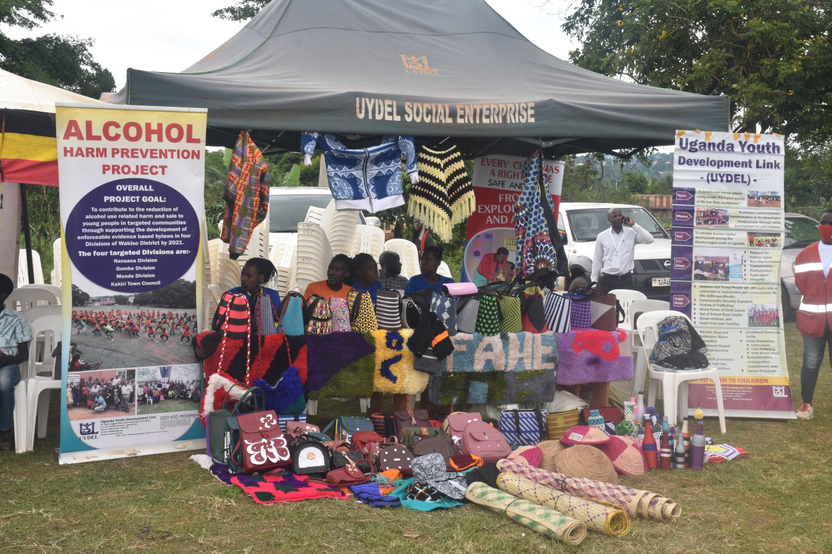

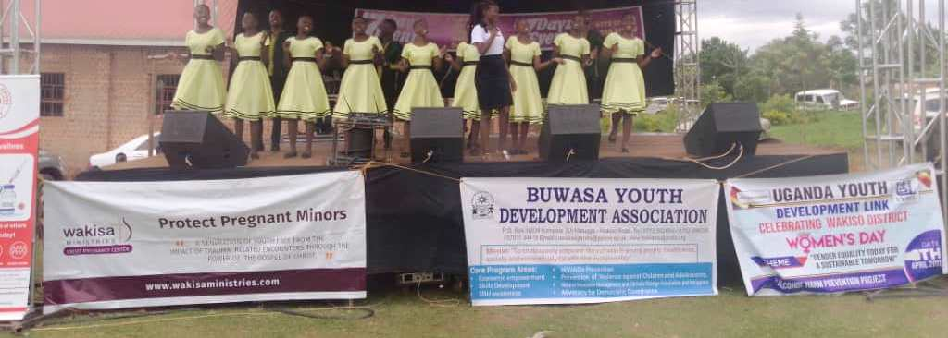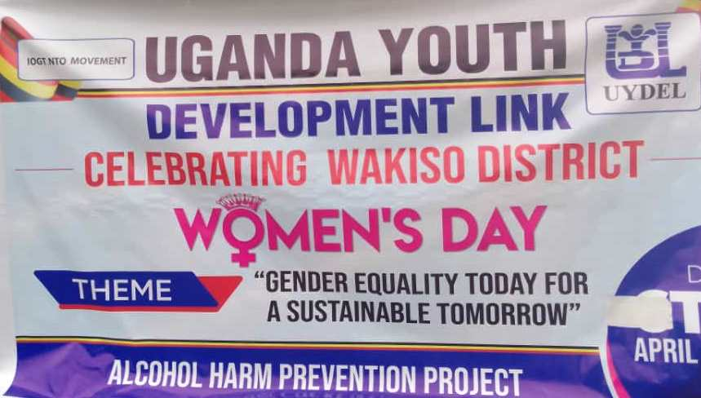

Date: 21st-04-2022
Venue: Mende sub county play ground
Organised by: Wakiso district.
Compiled by: Lubega Andrew
Project officer
Introduction
International Women's Day is a global holiday celebrated annually on March 8 to commemorate the cultural, political, and socioeconomic achievements of women. It is also a focal point in the women's rights movement, bringing attention to issues such as gender equality, reproductive rights, and violence and abuse against women.

The theme of International Women’s Day 2022 is “Gender equality today for a sustainable tomorrow”
The aim of this theme is to recognize the role of women and girls who are taking responsibility for adapting, mitigating and responding to climate change, to create a more sustainable future for all.
The theme also alignes with the priority theme for the upcoming 66th Commission on the Status of Women (CSW66): “Achieving gender equality and the empowerment of all women and girls in the context of climate change, environmental and disaster risk reduction policies and programmes”.
Wakiso district in collaboration with partners organised the commemoration of the international women’s day on the 21st -04-2022 at Mende sub county playground. The function was graced by the Hon. Hajjat Minsa Kabanda, Cabinet Minister of Kampala Capital City Authority.
Activities for the day
- Match past in Mende Sub county
- Blood donations
- Exhibitions by partners (NGOs and CBOs)
- School performance
- Appreciation and recognition of implementing partners
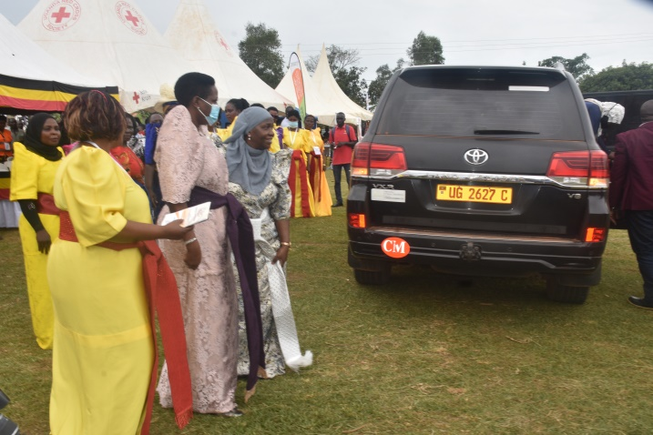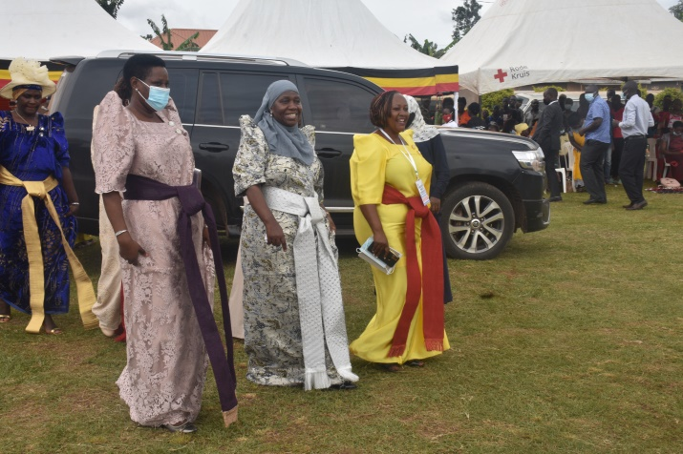
Arrival of the minister flanked by the RDC and the Chairperson women’s council

Inspection of the guard of honor
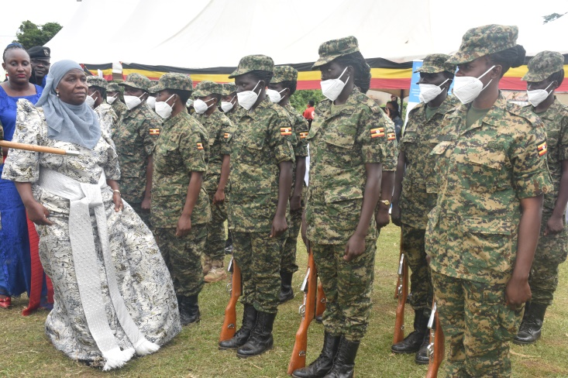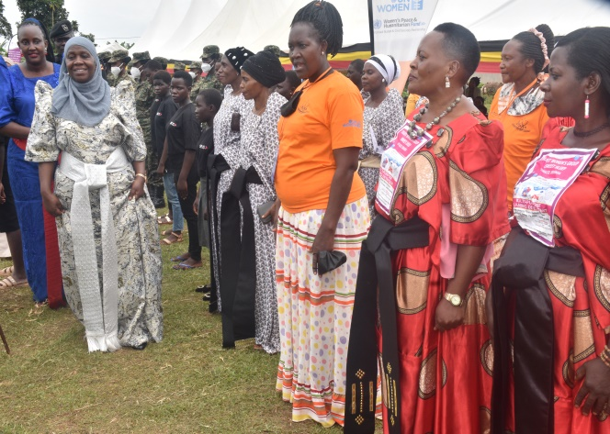
The honorable minister took time to inspect the UYDEL exhibition tent where we highlighted the work we do within Wakiso district aimed at contributing to the reduction of alcohol use related harm and sale to young people in targeted communities through supporting the development of enforceable evidence based by laws by 2022
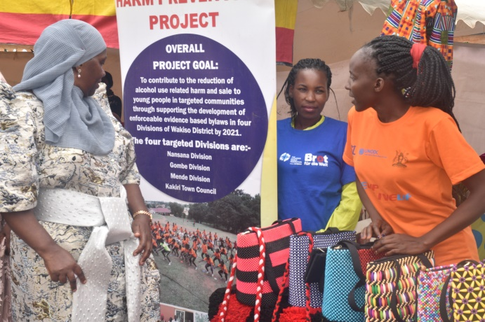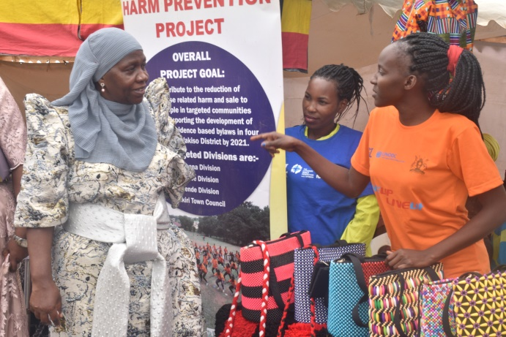
The team also showed products that are hand made by the young people under rehabilitation at the UYDEL centers in Makindye and Nakulabye.
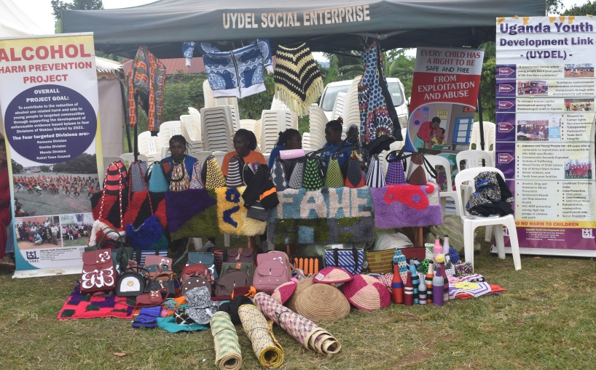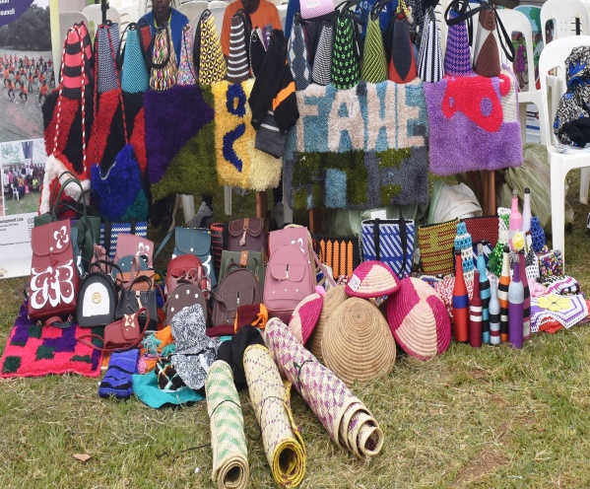
The minister also visited other exhibitors which included women groups, community based organisations and the children.
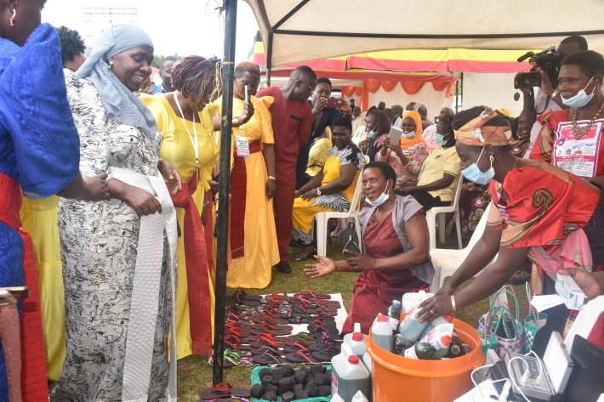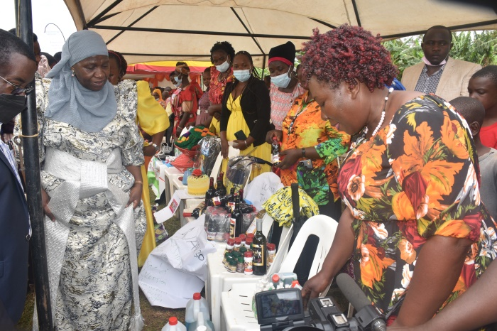
Uganda Youth Development Link(UYDEL) through the Alcohol Harm Prevention project funded by IOGT-NTO was much appreciated for the work done in th e local community and awarded a certifacte of recognition.
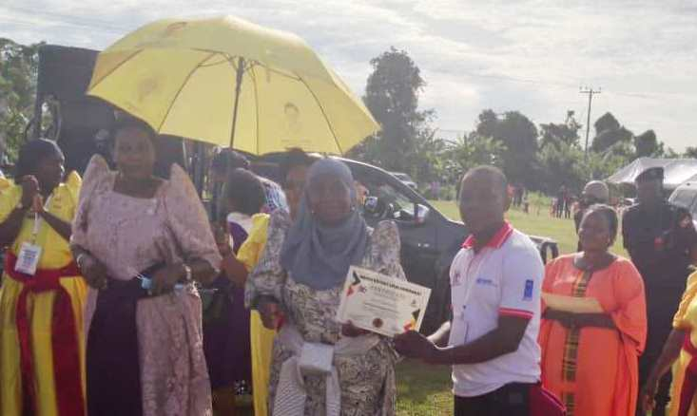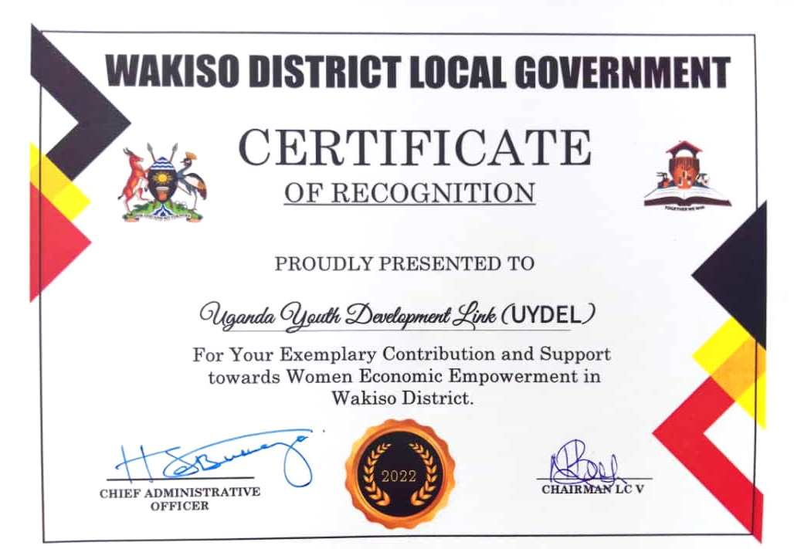
Andrew Lubega Project officer receiving certificate on behalf of the UYDEL Team
Conclusion.
Promoting gender equality and women’s empowerment can help deliver better environmental outcomes because without gender equality today, a sustainable future, and an equal future remains beyond our reach so let’s claim and strive for “Gender equality today for a sustainable tomorrow.

