School-based Prevention Programme
Prevention Programmes in schools are aimed at preventing students use drugs or preventing those who have started using drugs from advancing to severe drug use.
Children face many challenges like peer pressure, lack of social skills, academic issues, feelings of low self-esteem, fear of not living up to expectation and availability of alcohol and drugs in their environment.
Schools are often considered the ideal environment to start a drug prevention programme. This is because children spend about a quarter of their time in school and more when they are engaged in co-curriculum activities.
Our programme targets the whole school community which includes the students, teachers, parents, local community leaders, and religious leaders as all these people are connected in some ways within the community.
Our prevention programme focuses on promoting healthy lifestyle and well-being. We implement interventions to reduce modifiable risk factors and promote heathy behaviours.
We start our prevention programme at the primary school level with children aged 7 – 12 years old. We put them into two groups: lower primary aged 7 – 9 and upper primary aged 10 – 12 and we have different sets of activities for each group as their developmental age differ and require different tasks. The primary objectives of our school-based prevention programme are for students to learn social and development skills, and to make responsible decisions. Social skills are so important for these young people to be able to express themselves in ways that they are understood. Development skills like assertiveness enable students to stand up for themselves and avoid situations that are not right for themselves. Assertiveness also helps to build their confidence and resilience.
Students, teachers, parents, local community leaders and religious leaders also get information on drug use and the far-reaching negative consequences of drug use. They are also informed on family communication, monitoring and supervising their children’s work and activities at home. The stakeholders are well informed about the nature of our prevention programme and that their participation is important. Prevention is about educating the community about the importance of promoting healthy lifestyle and wellbeing and becoming a role model to others in the community.
Our prevention programme is conducted in 3 series where we spend half a day with the school community each time. We develop relevant modules that will help to meet our objectives. An important part of our programme is the evaluation of the programme itself as that is how we can see the impact on the students. To do this, a longitudinal study is carried out by collecting data on key aspects of assertiveness at three different points in time. Since this programme involves intervention on participants, a control group is necessary to see if the impact is the direct consequence of the programme. Another facet to the evaluation approach is the adapted Guskey’s gauging impact at 5 levels of data which is not just looking at impact on participants only but to the surrounding community who are deemed as stakeholders in the outcome of the programme.

Some activities conducted during the first session of the programme

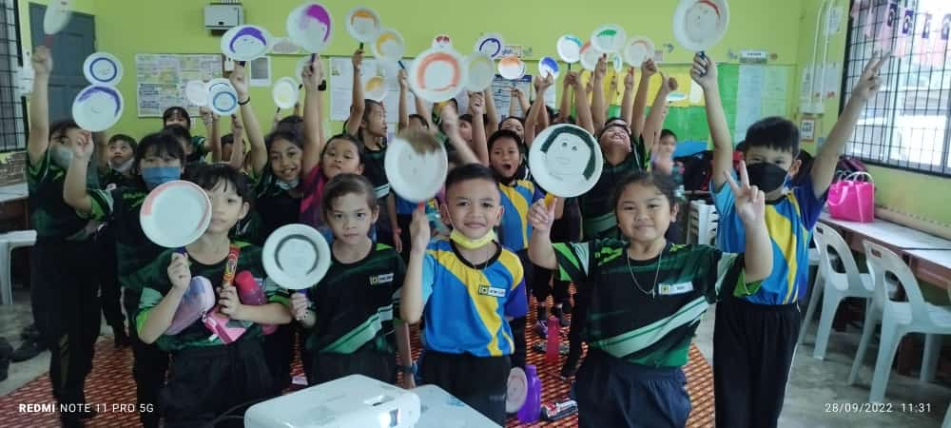
Young school children learning to express feelings

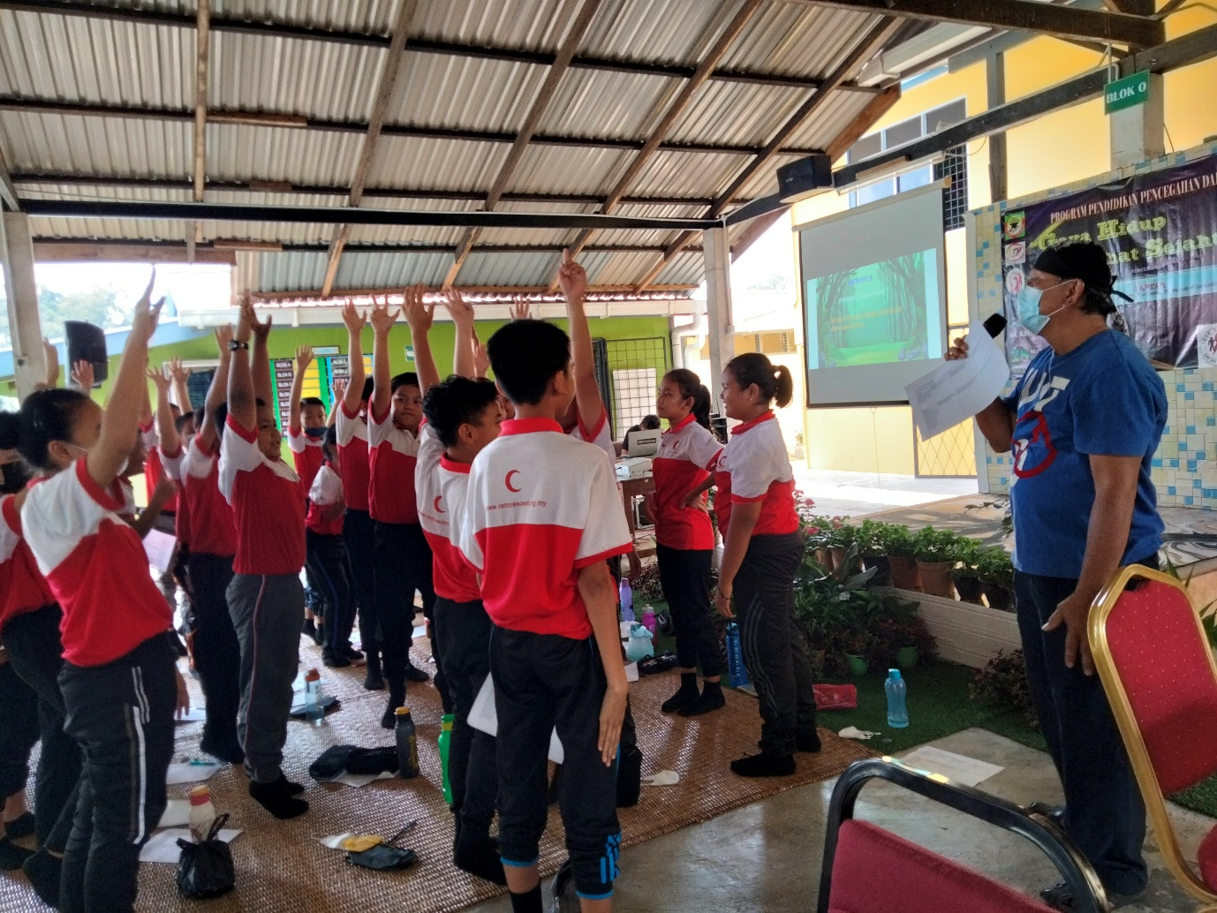
It is important for school children to learn how to make responsible choices and decisions

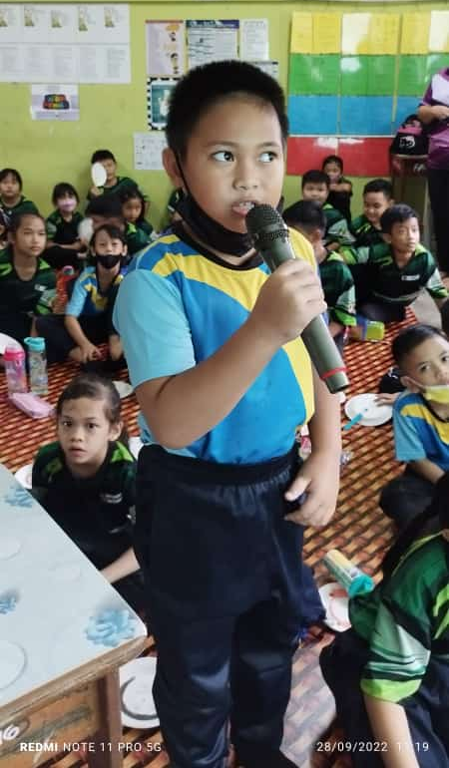
Expressing themselves with confidence

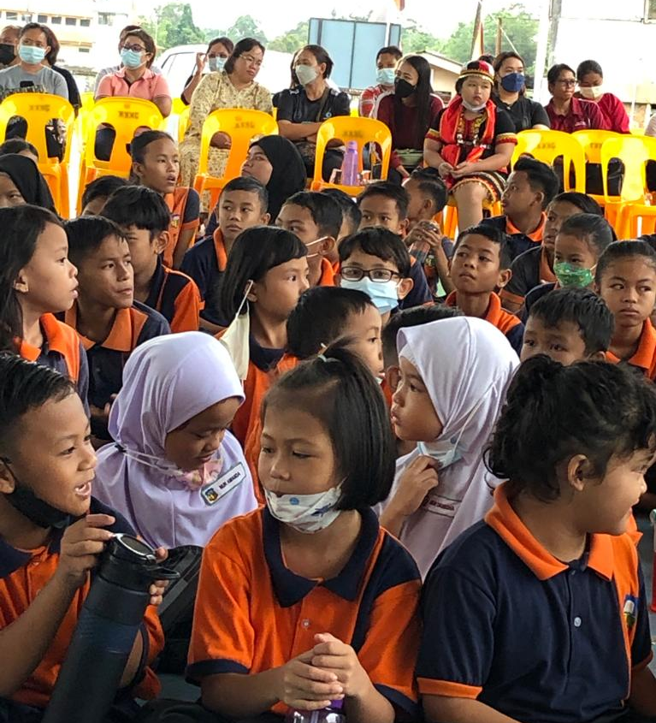
Parents are active participants, sitting behind the children

