ISSUP Global Webinar Proposal Form
Thank you for your interest in ISSUP Webinars. Kindly submit this Proposal Form at least 4 weeks before the planned event date, along with headshots or photos of speakers and moderators. ISSUP aims to support content that is evidence-based, supported by research, and utilizes non-stigmatizing language (please refer to "Terms to Avoid, Terms to Use and Why" by NIDA).
ISSUP may request additional information regarding the speakers and presentations upon submission and may provide appropriate feedback and guidance. Thank you.
Proposal Details
Please provide details of your webinar proposal under each of the following headings:
- Webinar Title: | Please provide a captivating and descriptive title for your webinar that succinctly reflects the main theme or focus of the session. Make it concise, clear and informative to attract participants.
- Topic Area: | Please indicate the primary subject matter or theme that the webinar will address, providing a brief overview to give potential attendees a clear idea of what to expect.
- Description: | Please provide a detailed but concise summary of the webinar content, including key points, discussion topics, and any activities or interactive elements planned. Highlight the relevance and significance of the topic to engage potential participants.
- Intended audience: | Specify the target audience for the webinar. Make sure to tailor the language and content of the webinar to meet the needs and interests of the intended audience.
- Learning outcomes | Clearly outline the learning objectives and goals that participants can expect to achieve by attending the webinar. Identify the knowledge, skills, or insights they will gain from the session.
- References | We value new references that we can add to ISSUP’s knowledge share, where applicable. Kindly provide details of references used to draft the content of the webinar.
- Preferred Dates and Times: | Please provide options for potential dates and times for the webinar, considering the availability and convenience of both presenters and participants. Consider different time zones to accommodate a diverse audience.
- Language(s): | Indicate the language(s) to be used in the webinar, and whether interpretation might be offered.
- Presenter(s): | Please include the names, titles, and affiliations of all presenters involved in the webinar. Provide brief biographies highlighting their expertise and qualifications related to the topic.
- Presenter Email(s): | Share contact information for each presenter, including email addresses, to facilitate communication and coordination with participants and organisers.
- Moderator(s): | List the names, titles, and affiliations of any moderators who will facilitate the webinar. Briefly introduce, where applicable, their background and experience.
- Moderators Email(s): | Include email addresses for the moderators to streamline communication and ensure smooth coordination before, during, and after the webinar.
Your details
Name and title:
Organization/Institution:
Country:
Email:
Please continue to Terms and Conditions below…

Proposal review process:
This diagram outlines the essential steps a webinar proposal goes through at ISSUP, from initial submission to final scheduling and posting.
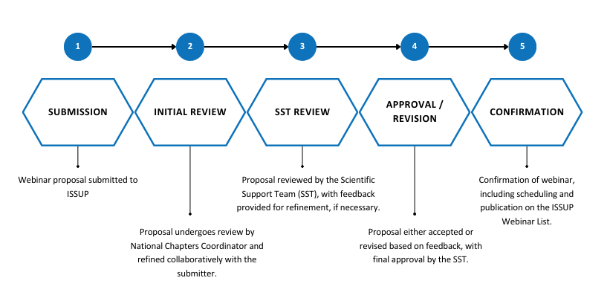
Terms and Conditions
Webinar sessions will be recorded and available for future viewing. Please provide permission to record the proposed webinar and share it online as required.
I give ISSUP permission for the event to be recorded and shared online (please tick) ☐
- Your topic should be related to research and practice associated with the professional education of substance use prevention, treatment and recovery professionals. It should be of interest to ISSUP members and the wider drug demand reduction community.

- A webinar session will typically last for an hour, which allows for 45 minutes of presentation and 15 minutes introduction and Q&A.

- You will receive a notification as to whether your webinar has been accepted within three weeks of submission to ISSUP.

- Once your webinar proposal has been accepted, the ISSUP team will contact you to provide a brief biography and, (if available), an image for each presenter.

- The ISSUP team will contact you regarding scheduling. Presentation times are usually scheduled between 10:00am and 4:00pm (London/UK time), on normal business days (Monday-Friday). Other timings are at the discretion of ISSUP.

- Scheduling is dependent on availability, but we will do our best to accommodate your requested date and time.

- No proprietary, confidential or sensitive information should be included in any presentation.

- The focus of ISSUP webinars is on the principles and practice of education, learning and the sharing of professional knowledge. Commercial sales pitches and product/company endorsements are not allowed.

- Webinar hosts must be available for a practice session 1 week prior to the presentation.

- Presenters must provide ISSUP with a copy of the presentation (slides etc.) a minimum of 48 hours in advance of the scheduled event date.

- On the day of the webinar, the webinar presenters will conduct the webinar in a quiet space. You should schedule at least 80 minutes for the webinar: 20 minutes prior to the webinar to set up and test the technology with our team and 60 minutes for the actual webinar.

- ISSUP takes webinar security seriously and you agree to use the software platform specified by our team.

I agree to the terms and conditions (please tick) ☐

Name:
Date:

